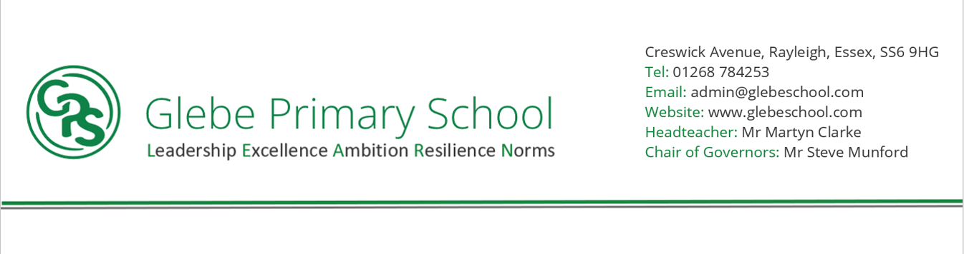

Statement of implementation

At Glebe Primary School, we have used the National Curriculum alongside specific year group topics, to allow our children to gain the necessary knowledge and skills to make progress. We recognise that the curriculum encompasses all areas of learning and we provide learning which is broad and balanced, and makes clear links across all subjects to give children a clear rationale for completing their work In order to allow children to remember key skills and knowledge, children revisit them over the course of a key stage. Wherever possible, reading, writing and Maths activities are linked across lessons so that children are confident in the links between all the subjects and this embeds their knowledge in a more meaningful way.

For some subjects, outcomes are presented in more creative ways either through use of media, use of computers, class presentations and discussions. These still represent the children’s best work but also demonstrate individuality of learning which we expect from our pupils. These creative learning opportunities act as a hook or celebration of work and give learning purpose, ensuring the work carried out is memorable, and meaningful links are made between different areas of the curriculum.

Alternative enrichment experiences, such as trips, ‘enrichment days’, use of Media and Outdoor Learning provide the children with vast learning experiences outside the classroom environment which helps enhance their understanding, school experience and learning.