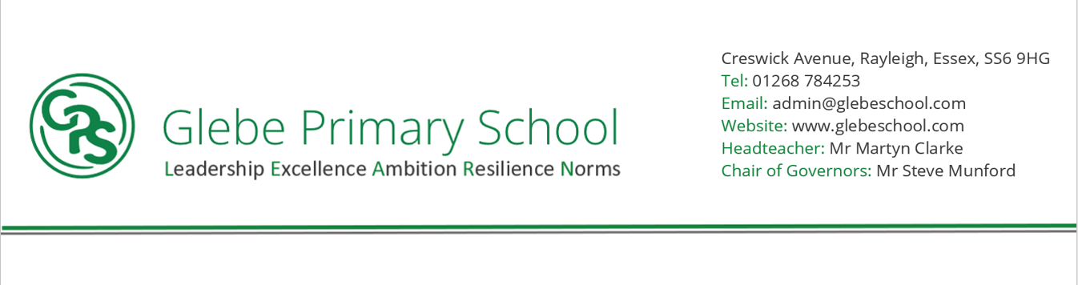

Creswick Avenue, Rayleigh, Essex, SS6 9HG

Tel: 01268 784253

Email: admin@glebeschool.com

Website: www.glebeschool.com

Headteacher: Mr Martyn Clarke

CEO: Mrs Katharine Dines

Creswick Avenue, Rayleigh, Essex, SS6 9HG

Tel: 01268 784253

Email: admin@glebeschool.com

Website: www.glebeschool.com

Headteacher: Mr Martyn Clarke

Chair of Governors: Mr John Archer

Creswick Avenue, Rayleigh, Essex, SS6 9HG

Tel: 01268 784253

Email: admin@glebeschool.com

Website: www.glebeschool.com

Headteacher: Mr Martyn Clarke

Chair of Governors: Mr John Archer

**Music Development Plan**

2024-2025

**Headteacher:** Mr Martyn Clarke

**Music Lead Teacher:** Mrs Amy Holoahan

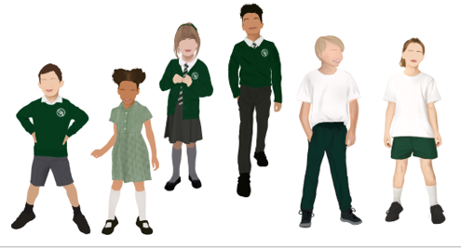

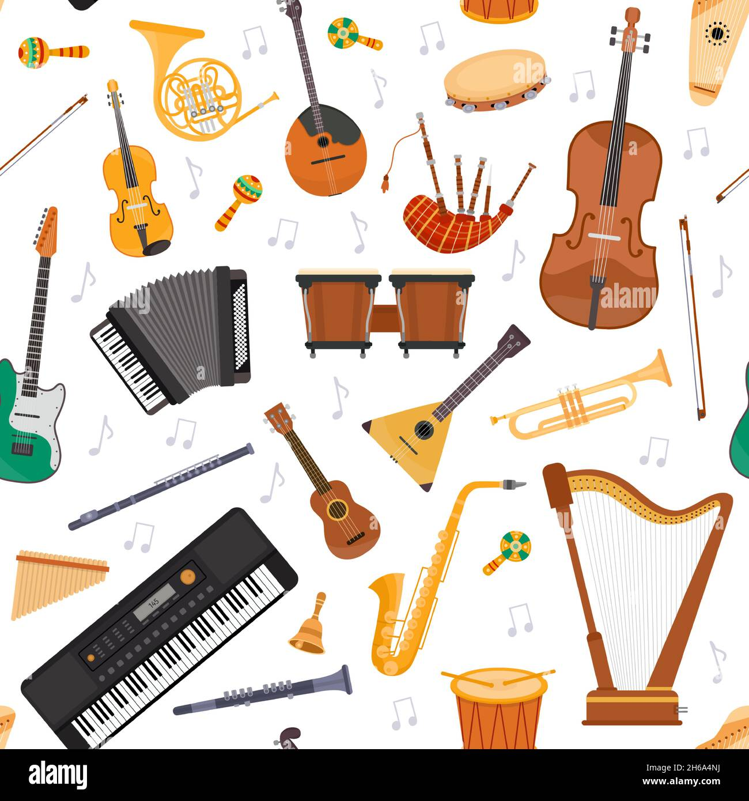



**Our Vision**

At Glebe Primary School, is a subject and skill that children of all abilities can excel in and a good proportion of the students at Glebe have these skills that need to be showcased and developed. This is why our aim is in ensure all children gain a firm understanding of what music is through listening, singing, playing, evaluating and composing across a wide variety of historical periods, styles, traditions, and musical genres. We aim to develop a curiosity for the subject and we are committed to ensuring children understand the value and importance of music to their own and others’ lives and wellbeing, as well as acknowledging the impact music has in the wider community. All children have access to music regardless of their academic ability, race, ethnicity, background and language. SEND pupils are actively encouraged to participate fully as music is often an area of the curriculum which allows them to excel. Children are also able to use their musical skills, knowledge, and experiences to involve themselves in music, in a variety of different contexts.

The objectives of teaching music at Glebe Primary School are:

* All children are given the opportunity to perform, listen to, review and evaluate their own and others music across a range of periods, genres and styles.
* All children are given the opportunity to explore musical terms and notations.
* All children are given the opportunity to sing and use their voices to express themselves, create and compose music.
* All children are given the opportunity to learn a musical instrument to enable them to create and compose music with these instruments.
* All children are given the opportunity to understand how music is created and produced.



**Self-Assessment**

|  |  |  |  |
| --- | --- | --- | --- |
| **Area** | **Category** | **Description** | **Comments** |
| **Curriculum**  **Music** | Timetabling | Not all classes receive a regular music lesson each week |  |
|  |  | There is a regular timetabled curriculum music lesson for all children but not a full hour each week when combined with other provision |
|  |  | There are regular timetabled curriculum music lessons in all years plus other provision which totals 1 hour per week for all children (can include singing assemblies etc.) |
|  | Curriculum design | Musical activity takes place in some or all classes but not necessarily tied to a formal school-wide curriculum |  |
|  |  | There is a whole school curriculum in place for music which covers all parts of the National Curriculum |  |
|  |  | There is a whole school curriculum in place which clearly maps progress and skills across the key stages. Additional aspects are embedded into the planning such as whole class instrumental music,  school performances and special musical events |  |
|  | Assessment | We have limited capacity and/or expertise for  assessing musical progress |  |
|  |  | Class teachers record progress using video/audio  recordings or written notes |
|  |  | Progress is clearly recorded using video/audio or written notes and ML works closely with class teachers to monitor and support this process. There  are opportunities for pupils to self and peer assess their work planned into lessons |
|  | Quality of  teaching | It is uncertain whether all teachers are teaching  music to a good standard each week |  |
|  |  | Music teaching is generally of a good standard, but there is still a need for further CPD and support in  some areas |  |
|  |  | Music teaching is consistently good quality throughout school and is monitored and supported  well over the year |  |
|  | EYFS music | It is uncertain how much music takes place in  Nursery/Reception classes or whether it is of consistently good quality |  |
|  | Music is regularly planned in to EYFS timetables and is generally of a good standard though some CPD  and support may still be beneficial |  |
|  | Singing is an integral and essential part of EYFS life. Songs and activities are appropriate to developing  voices and carefully chosen to support early progress |  |

|  |  |  |  |
| --- | --- | --- | --- |
| **Whole class instrumental provision** | Whole class | No whole class instrumental provision is currently in  place |  |
| Children learn to play an instrument as part of whole  class learning during their time in school |
| Whole class learning is fully integrated into the wider music curriculum and is deliberately placed for pupil progression. The instrument/s are also  selected for progression and quality of delivery is consistently good. |
| Duration | Children are given a ‘taster’ on one or more instruments in whole class lessons which is less than  one year in duration |  |
| Children are given a full year to learn an instrument and as such develop basic skills and knowledge securely in that time. There are opportunities during the year for the children to perform to others. Some children choose to carry on with that instrument (or  a related instrument) at the end of the year |
| **Singing** | School / KS / Year group singing | Children only occasionally sing together as part of a larger group, maybe tied to performances or  calendar events. | Continue to embed singing in assemblies within the school. |
| Children sing together all or most weeks as part of a  singing assembly or similar |
| Regular singing assemblies are led by a specialist. Singing is an important and integral part of curriculum lessons, delivered by confident teachers  skilled in delivering healthy singing. |
| Choirs | There are currently no school choirs taking place  regularly | Choir take part in the junior music festival, young voices, infant music festival – these need to move from whole class to a specific choir moving forward. |
| There is at least one school choir which meets  regularly led by a skilled teacher |
| There are one or more school choirs, led by skilled singing leaders which have opportunities to perform regularly and/or take part in wider community  events |
| **Instrumental and vocal lessons** | Tuition | There are limited or no opportunities for children to  learn to play an instrument in school |  |
| Children have the opportunity to learn an instrument in at least one family of instruments. There are occasional opportunities for children to  perform on their instruments |
| There are opportunities for children to learn an instrument in various instrumental families with regular opportunities to perform to others. School regularly engages and plans with their instrumental  tutors allowing for a consistent approach to music provision |

|  |  |  |  |
| --- | --- | --- | --- |
|  | Whole class follow on | There are currently no opportunities for children to continue learning an instrument they have started in whole class teaching | Additional cost of these sessions has been a barrier |
| There are opportunities for children to continue learning the instrument (or a closely related  instrument) after whole class lessons have finished |
| There are opportunities for children to continue learning the instrument (or a closely related instrument) after whole class lessons have finished  and a good number of children choose to do this |
| Ensembles | There are currently no instrumental ensembles in school or only very occasional ensemble playing  opportunities | Need to explore Bandit. |
| Children learning some instruments have the chance to play in a school ensemble which rehearses  regularly |
| A child learning any instrument in school has the chance to play that instrument in an ensemble. There are regular performing opportunities with the group. Routes of progression for children including music centres and CLYM are signposted as  appropriate |
| **Inclusion** | Inclusion | There are no provisions in place to support less affluent families. There is little adaptation in music lessons for children with additional needs or varying  ability |  |
| School applies for bursaries or finds other ways to support children from low income backgrounds to learn an instrument.  Curriculum and instrumental lessons are planned to cater for children with carrying needs and ability.  Pupils have opportunities to listen to and engage with music from different cultures, traditions and  eras |
| All staff (including visiting staff) are fully aware of any relevant additional needs in their classes.  Lessons are well differentiated to cover all needs and abilities. Children are sensitively guided to learning an appropriate instrument for their specific needs  Pupils have opportunities to listen to and engage with music from a wide variety of different cultures, traditions and eras |
| **Wider involvement** | Hub participation | The school generally don’t engage much with the local music offer or other partner organisations in music | Infant and Junior music festivals |
| There is some level of engagement with Essex Music Services/SEESMA with occasional participation in local  events |
| The school has strong partnerships with Essex Music Services and/or other organisations with  regular participation in local events, workshops |
| CPD | There is little capacity within school for the music  lead or other staff to engage with music CPD | Charanga training.  Subject leader staff meeting. |

|  |  |  |  |
| --- | --- | --- | --- |
|  |  | Music lead has occasional opportunities to access  CPD, other staff only rarely |  |
| Music lead is able to access a higher level of music CPD and other staff in school are also accessing CPD or a higher level of support from the Music Lead or  elsewhere |
| Links with other schools | There are currently no musical links with other  schools |  |
| Some links are made with peer schools, other MAT schools, religious school networks or cluster networks. Occasional musical events may take place within these communities or resources and expertise  are shared. |
| Strong links are made with other schools with opportunities to share resources, expertise and to organise events. There are strong links made to local  secondary schools for Y6 transition. |
| Live music | There are currently no opportunities for children to  experience and enjoy live music | Christmas productions |
| There are occasional opportunities for some children to experience live music either on a trip or from  visiting musicians |
| All children have opportunity to experience live  music over the course of the school year. |
|  |  |  |  |



**Our Development Plan**

|  |  |
| --- | --- |
| MUSIC DEVELOPMENT PLAN | |
| **Overall objectives** | At Glebe, music is a way for children to express their emotions enjoyably and creatively. It plays an important role in personal development. At Glebe, we aim to provide opportunities for all children to create, play, perform, listen, analyse and enjoy music across a wide range of periods, genres and styles. We are committed to ensuring children understand the value and importance of music in the wider community and aim to provide opportunities for children to use their musical skills, knowledge and experiences to involve themselves  in music, in a variety of different contexts. |
| **Key components** | *Music curriculum, including use of music technology – EYFS, KS1, KS2, SEND* Teachers deliver music following the Charanga programme, designed specifically for the teaching of music in primary schools. Charanga lessons are planned in sequences to provide children with the opportunities to review, remember, deepen and apply their understanding. Teachers are able to produce inclusive lessons for all children to access the musical curriculum in a fun and engaging way, further promoting a love of learning.  *Classroom instrumental teaching*  Throughout their primary music curriculum journey, children will learn how to play Glockenspiels within our music scheme. Playing various instruments enables children to use a range of methods to create notes, as well as how to read basic music notation.  *Links with external music organisations*  We have links with Essex Music Service and SEESMA, who offer whole class music teaching and support with our musical offering throughout school. |
|  | *Music CPD*  Music leads have CPD opportunities through the year and are able to use staff meeting time to offer teaching staff further CPD. Training is offered annually through Charanga and the music lead attends locally run training to disseminate to staff.  *Performance opportunities*  At Glebe we plan performance opportunities across the year. At Christmas, all children have the opportunity to perform to other years groups, parents and local community. Our year 6 children put on an end of year performance to the school and families each year.  We also perform at the Cliffs Pavilion each year at the Junior music festival and our younger children have previously participated in the infant music festival. We also perform at the O2 in Young Voices. |
| **Communications** | Using ClassDojo, we will inform parents of musical opportunities throughout the school year. |
| **Budget, materials and staffing** | -*Essex Music Services offers whole class instrumental teaching, small group teaching and one to one lesson’s at a subsidised cost. They also offer funded places for LAC and PLAC children.*  -We are offered subsidized access to a comprehensive teaching scheme on Charanga which has been adapted and mapped out for each group to support progression and coverage. |



**Key Priorities**

|  |  |  |  |
| --- | --- | --- | --- |
| KEY AREAS DEVELOPMENT PLAN | | | |
| **AREA** | **ACTIONS** | **DATE TO BE COMPLETED BY** | **EVALUATION** |
|  |  |  |
| **Curriculum music** | Introduce further live music opportunities for the school.  Continue to monitor music teaching throughout the school, use pupil interviews, lesson observations and teacher questionnaires using subject spotlights. Offer CPD where needed. | Planned across the academic year 2024/25 |  |
| **Whole class instrumental** | Sign up for further whole class instrumental lessons.  Reach out to parents to gauge interest in paid instrumental lessons | September 24 |  |
| **Singing** | Continue to implement singing practice in class and perform in assembly. | Through 24/25 |  |
| **Instrumental/ vocal teaching** | Implement Banit! Children learn instruments as part of an ensemble and perform. Look in to further instrumental teaching opportunities. | 24/25 |  |
| **Inclusion** | Reach out to the LA for further training on musical communication to support strategies on EHCP | October 2024 |  |
| **Wider involvement** | Book CPD for music leaders. Book Live music opportunities. | October 24 |  |